Lesson 11

**Movie Review Storage**



Create a Movie Review storage app that stores all movie reviews searched by a user. The movie reviews are to be stored locally and not on the server. You found out from your friend that you are not able to store the movie reviews using cookies due to the memory limitations. He proposed that you use HTML5 local storage instead. Find out the similarities and differences between cookies and local storage.

**Requirements:**

Index.php – Retrieve all movie reviews from the local storage and display on the page

searchMovie.php – Allow the user to enter the movie title, year and plot to search OMDB API web service. Display the movie details: Title, Released year, Runtime, Genre, Actors and Plot. Store the movie review into local storage.

Home Page

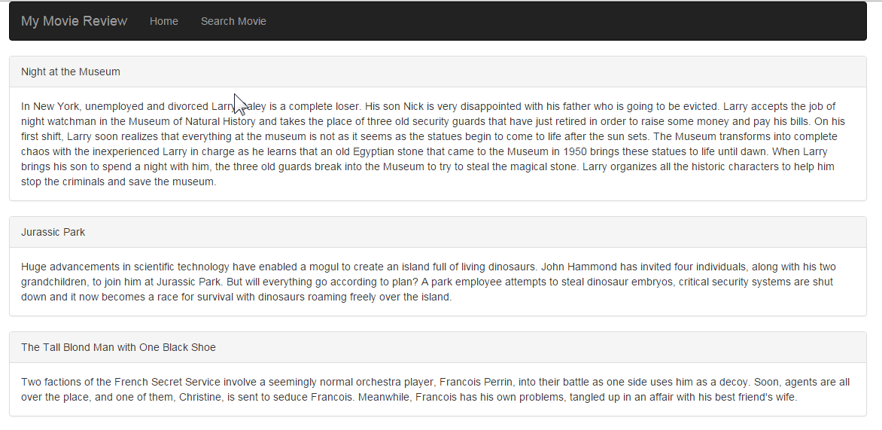

Search Movie

